***SOLUTION***

**ICA DATABASE**

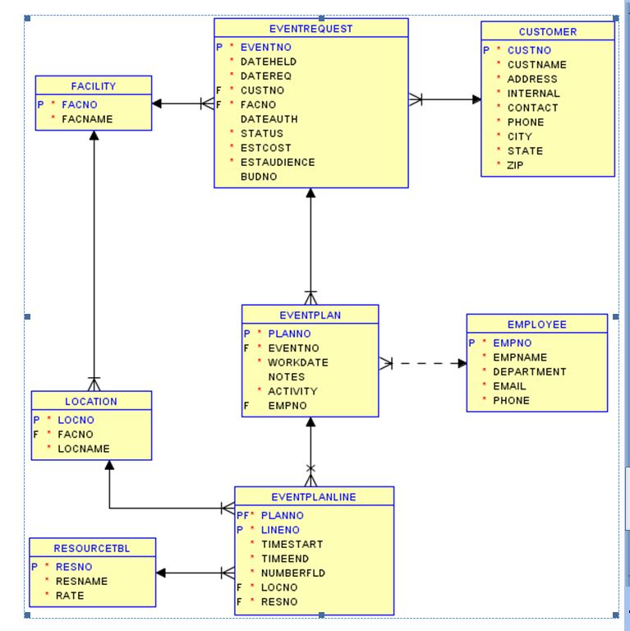

**CUSTOMER TABLE**

SQL> create table CUSTOMER

(CUSTNO VARCHAR2(8) NOT NULL CONSTRAINT PK PRIMARY KEY,

CUSTNAME VARCHAR2(20) NOT NULL,

ADDRESS VARCHAR2(20) NOT NULL,

INTERNAL CHAR(1) NOT NULL,

CONTACT VARCHAR2(10) NOT NULL,

PHONE VARCHAR2(10) NOT NULL,

CITY VARCHAR2(20) NOT NULL,

STATE VARCHAR2(10) NOT NULL,

ZIP VARCHAR2(10));

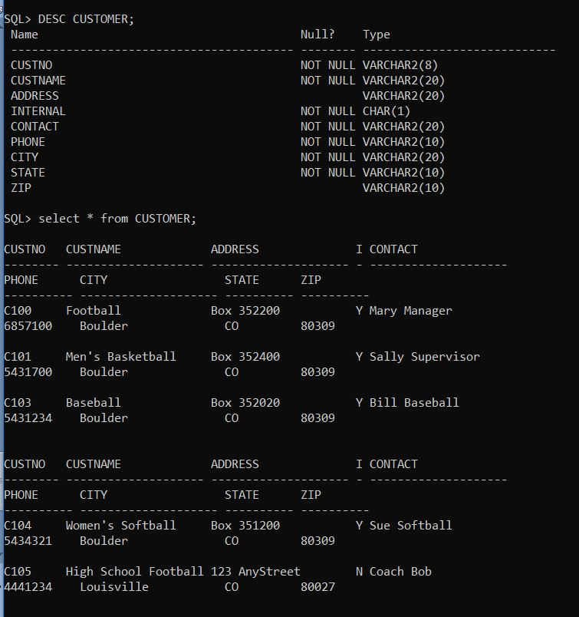

**FACILITY TABLE**

SQL> create table FACILITY

(FACNO VARCHAR2(8) NOT NULL CONSTRAINT PK2 PRIMARY KEY,

FACNAME VARCHAR2(20),

CONSTRAINT UNQ1 UNIQUE(FACNAME));

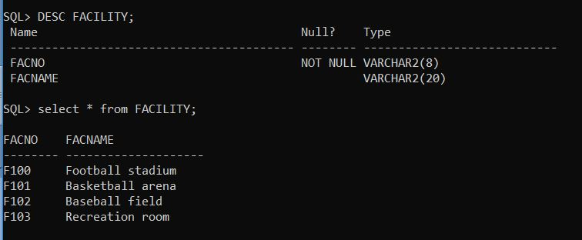

**EVENTREQUEST TABLE**

SQL> create table EVENTREQUEST

(EVENTNO VARCHAR2(8) NOT NULL,

DATEHELD DATE NOT NULL,

DATEREQ DATE NOT NULL,

CUSTNO VARCHAR2(8) NOT NULL,

FACNO VARCHAR2(8) NOT NULL,

DATEAUTH DATE,

STATUS VARCHAR2(20) NOT NULL,

ESTCOST INT NOT NULL,

ESTAUDIENCE INT NOT NULL,

BUDNO VARCHAR2(10),

CONSTRAINT PK1 PRIMARY KEY (EVENTNO),

CONSTRAINT VALIDSTATUS CHECK ( STATUS IN ('APPROVED','DENIED','PENDING')),

CONSTRAINT CHK2 CHECK (ESTAUDIENCE > 0) ,

CONSTRAINT FK2 FOREIGN KEY (FACNO) REFERENCES FACILITY,

CONSTRAINT FK1 FOREIGN KEY (CUSTNO) REFERENCES CUSTOMER);

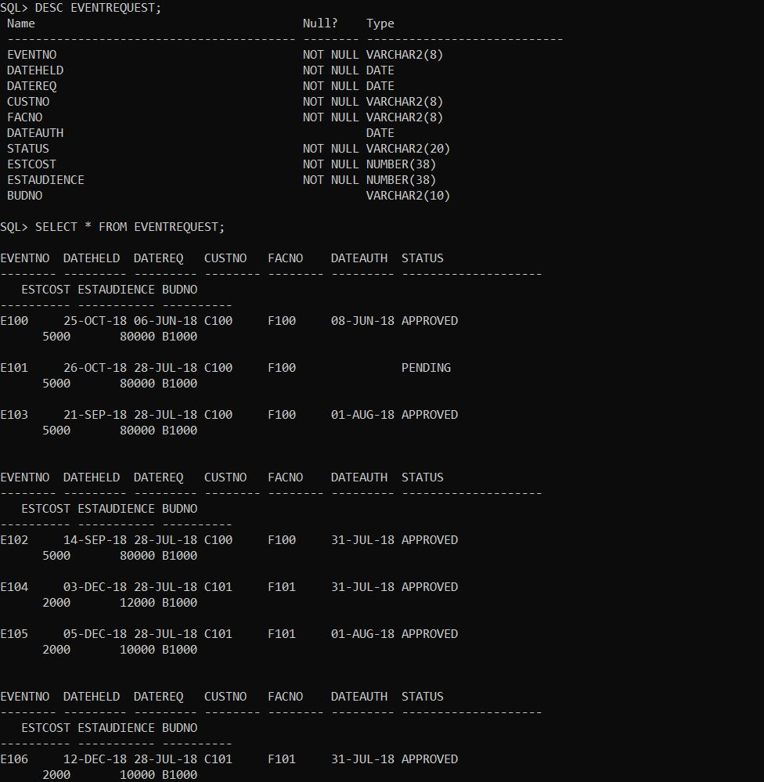

**EMPLOYEE TABLE**

SQL>create table EMPLOYEE

(EMPNO VARCHAR2(8) NOT NULL CONSTRAINT PK3 PRIMARY KEY,

EMPNAME VARCHAR2(20) NOT NULL,

DEPARTMENT VARCHAR2(20) NOT NULL,

EMAIL VARCHAR2(20) NOT NULL,

PHONE VARCHAR2(20));

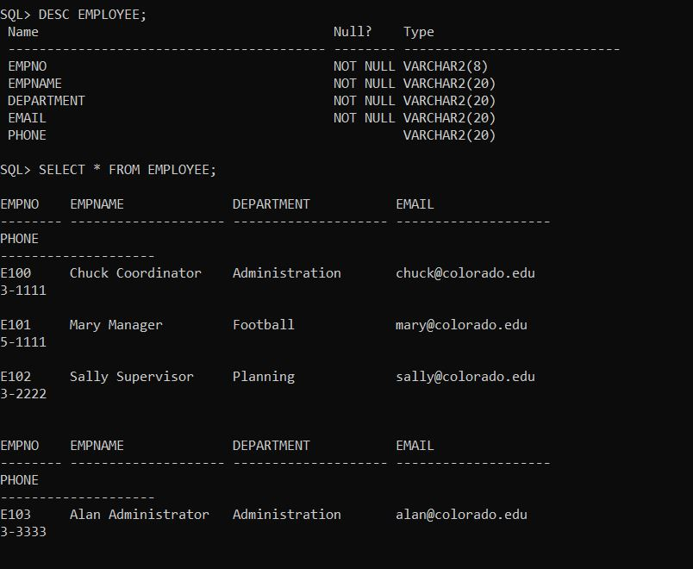

**EVENTPLAN TABLE**

SQL>create table EVENTPLAN

(PLANNO VARCHAR2(8) NOT NULL CONSTRAINT PK4 PRIMARY KEY,

EVENTNO VARCHAR2(8) NOT NULL,

WORKDATE DATE NOT NULL,NOTES VARCHAR2(20),

ACTIVITY VARCHAR2(20) NOT NULL,

DATEAUTH DATE,

EMPNO VARCHAR2(8) NOT NULL,

CONSTRAINT FK3 FOREIGN KEY (EVENTNO) REFERENCES EVENTREQUEST,

CONSTRAINT FK4 FOREIGN KEY (EMPNO) REFERENCES EMPLOYEE);

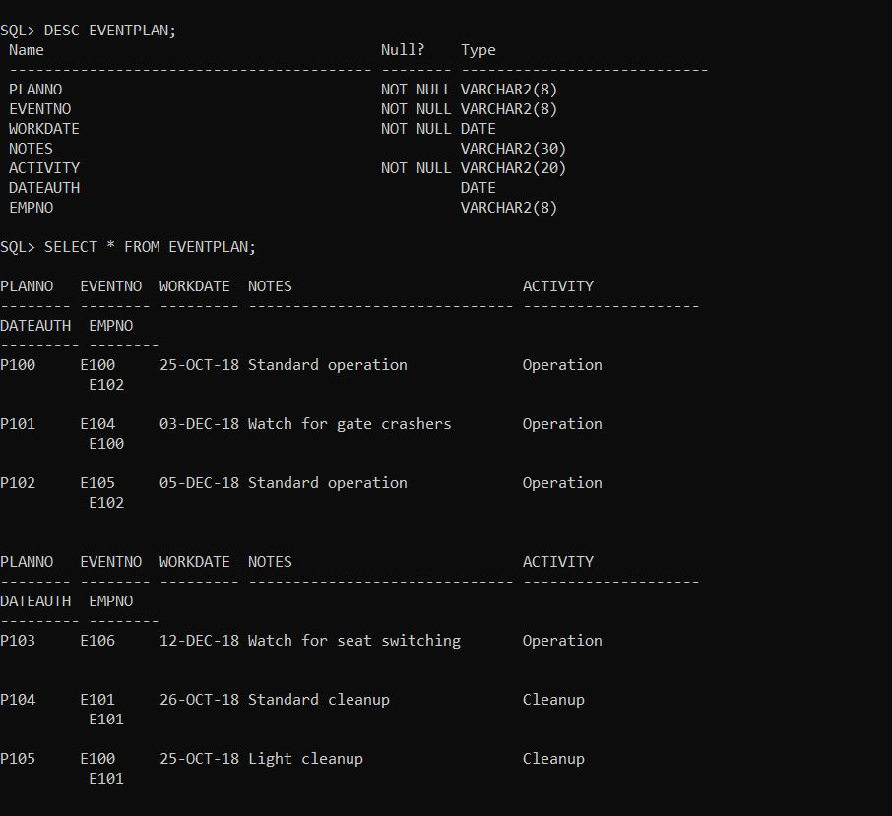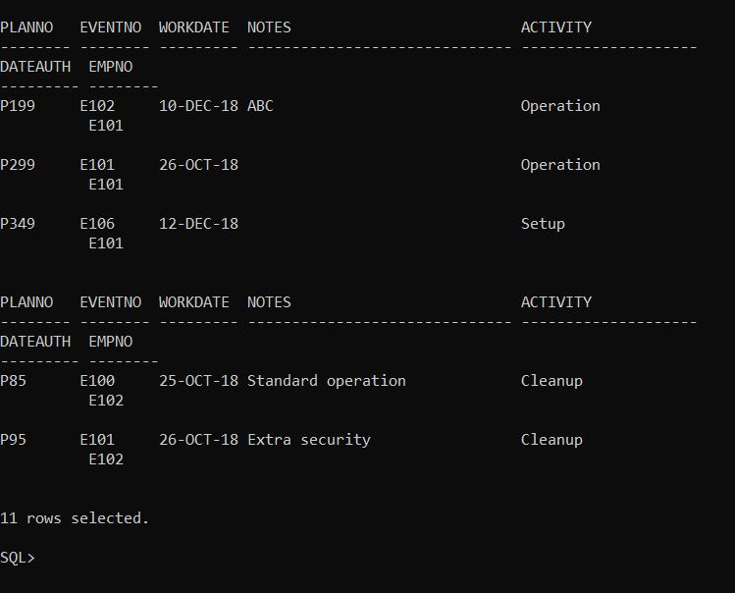

**LOCATION TABLE**

SQL>create table LOCATION

(LOCNO VARCHAR2(8) NOT NULL CONSTRAINT PK5 PRIMARY KEY,

FACNO VARCHAR2(8) NOT NULL,

LOCNAME VARCHAR2(20) NOT NULL,

CONSTRAINT FK5 FOREIGN KEY (FACNO) REFERENCES FACILITY);

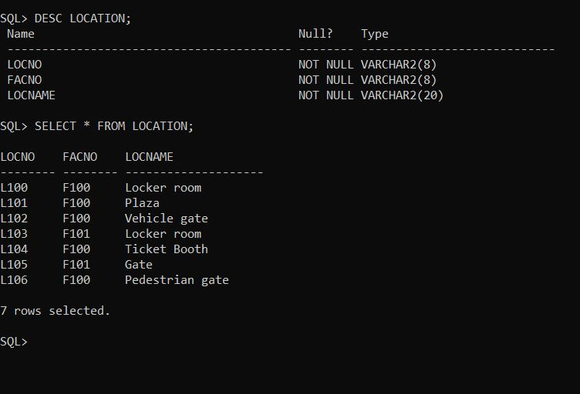

**RESOURCETBL TABLE**

create table RESOURCETBL

(RESNO VARCHAR2(8) NOT NULL CONSTRAINT PK6 PRIMARY KEY,

RESNAME VARCHAR2(8) NOT NULL,

LOCNAME VARCHAR2(20) NOT NULL,

RATE INT);

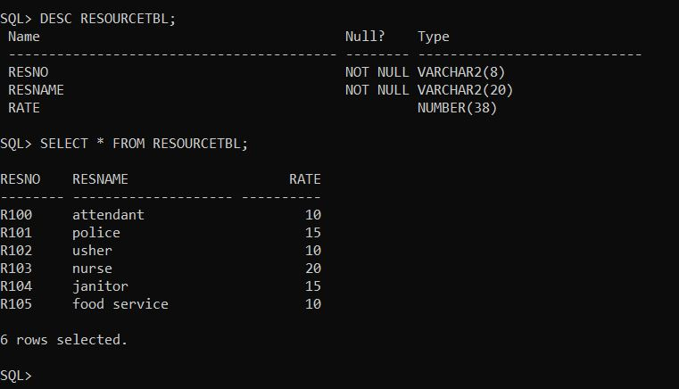

**EVENTPLANLINE TABLE**

SQL>create table EVENTPLANLINE

(PLANNO VARCHAR2(8) NOT NULL,

LINENO VARCHAR2(8) NOT NULL,

TIMESTART DATE NOT NULL,

TIMEEND DATE NOT NULL,

NUMBERFLD INT NOT NULL,

LOCNO VARCHAR2(8) NOT NULL,

RESNO VARCHAR2(8) NOT NULL,

CONSTRAINT PK7 PRIMARY KEY(PLANNO,LINENO),

CONSTRAINT FK7 FOREIGN KEY(PLANNO) REFERENCES EVENTPLAN,

CONSTRAINT FK8 FOREIGN KEY(LOCNO) REFERENCES LOCATION,

CONSTRAINT FK9 FOREIGN KEY(RESNO) REFERENCES RESOURCETBL,

CONSTRAINT TIMECHK CHECK (TIMESTART<TIMEEND));

